Experiment 2: Develop a Flight Reservation System using SaaS Workflow
Aim
To develop a Flight Reservation System using Zoho Creator for online flight booking and reservation management.
Software Used
- Zoho Creator
- Deluge Workflow
- Web Browser
Algorithm
- Create Customer Registration form.
- Create Flight Details form.
- Create Flight Search form.
- Create Booking form.
- Create Payment form.
- Validate seat availability.
- Generate booking confirmation.
- Display booking reports.

Output:
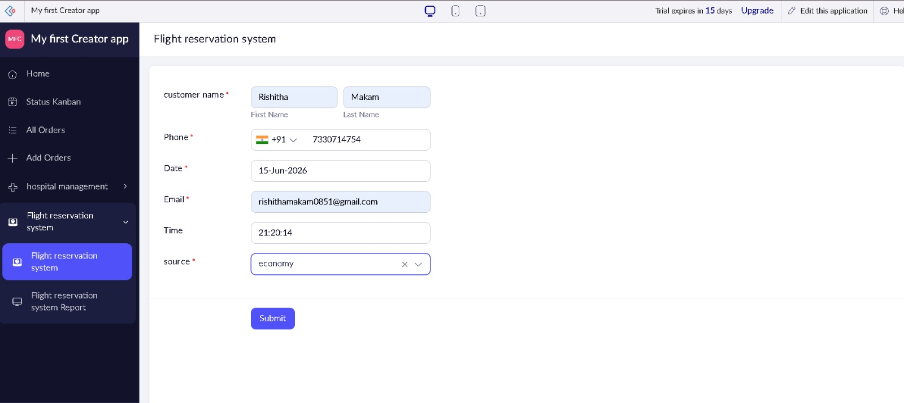

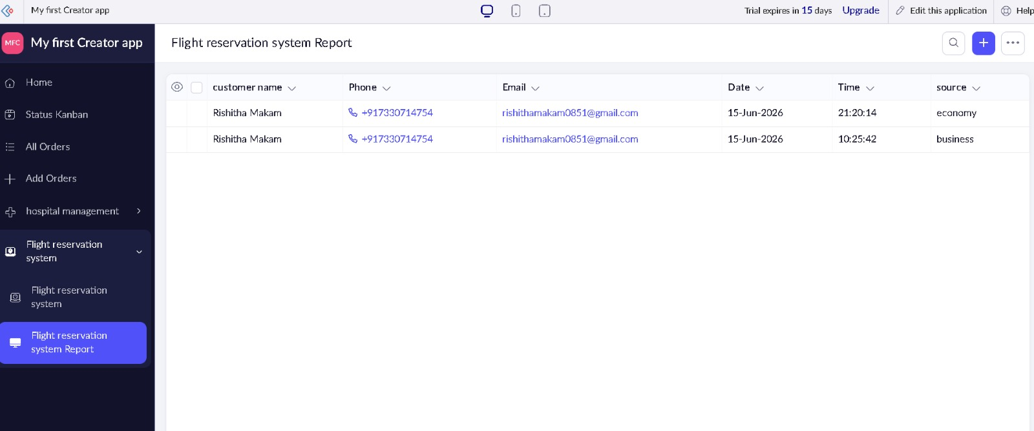

Result
A SaaS-based Flight Reservation System was successfully created, allowing users to search, reserve, and manage flight bookings online.

